Reading and Writing and GRIT
ZoomBookmarkSharePrintListenTranslate

Research shows that test prep is the "wrong skill" to teach. What students need to learn is tenacity, self-control, how to fail successfully.
Mary Burke, the principal of St. Anthony of Padua School in Camden, had some good news: St. Anthony’s was no longer last in math.
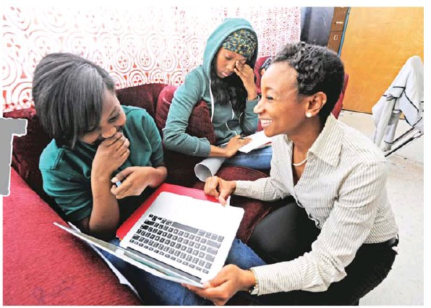
APRIL SAUL / Staff Photographer Teacher Lovelee Polite at Wissahickon Charter School with students Amirah Rose (left), Kamila Green. Wissahickon’s middle school director, Rebecca Benarroch, believes that teachers build kids’ resilience moment by moment.
The school’s point total in “First in Math,” an online program of timed games, had crawled from 19th place among diocesan schools to 16th in just a couple of weeks.
Upon hearing her announcement, the 162 students packed into the school’s basement room burst into applause.
For Burke, too, it was a moment worth celebrating — not because her students were suddenly math geniuses, but because they had persevered, worked hard, and refused to let failure topple them.
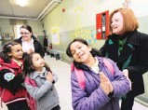
Burke is not the only educator with her eye on effort. Philadelphia School Superintendent William Hite included the goal of “cultivating academic tenacity” in his action plan for the district, released in January. In the last five to seven years, researchers and teachers across the country have begun to focus on qualities that may be more predictive of kids’ long-term achievement, and more crucial to their well-being, than performance on standardized tests: traits such as grit, zest, self control, curiosity, and resilience. “We’ve been emphasizing the wrong skills in our children, and using the wrong strategies to help develop those skills,” says Paul Tough, whose 2012 book How Children Succeed: Grit, Curiosity, and the Hidden Power of Character kick-started the conversation in several local schools and led to an educators’ conference in Mount Laurel last month.
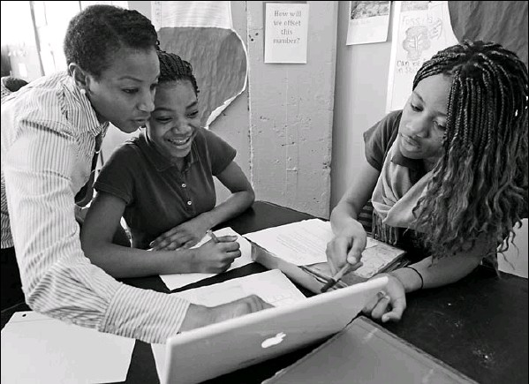
Teacher Lovelee Polite at Wissahickon Charter School with Ayanna Graham (left), 12, and Jordyn Caldwell, 13. A director wants to see the students become more academically tenacious, and also hopes they will find joy in learning.
Tough cites recent studies by psychologists, educators, and economists that all point to the same conclusion: The children who win spelling bees and chess tournaments, the ones who stay in college and who thrive as adults, are students with passion, persistence, and the ability to endure failure.
Some kids seem to be born with a healthy dose of those traits. But researchers say others can learn them — if not at home, then at school.
The question is how. There is no curriculum for Grit 101, no worksheet to drill students in curiosity. So schools are pulling from a grab bag of strategies, from “character report cards” to instruction in mindfulness, from team-building games to one-on-one mentorships.
This year at Julia R. Masterman school in Spring Garden, the academic magnet school whose students consistently ace standardized tests, principal Marjorie Neff ordered Brainology, a 10-week online tutorial created by a Stanford University professor in 2009, to help seventh graders develop a “growth mind-set” — the belief that intelligence is malleable rather than fixed and that people do better when they work harder.
And at Philadelphia’s Wissahickon Charter School, a K- 8 with an environmental focus, even kindergarten teachers note evidence of tenacity in their report- card comments: “He will stick with a piece of writing and return to it day after day until he writes a whole story.”
Angela Duckworth, a University of Pennsylvania psychology professor who published a test in 2007 to measure what she calls “grit” — a blend of purpose and persistence — says such qualities are relevant to educators because “learning is not easy. It is, like any other human endeavor, rife with failures, errors, missteps, and bad days. If we want schools to be in the business of building resilience, the question is: What counts? How do you know [if it’s working]? That is a real challenge that’s currently unsolved.”
In a kindergarten classroom at Wissahickon, teacher Aubrey White preps a roomful of wiggly kids for an exercise in “reading like a storyteller.” She hands each child a picture book and says, “The first time you read it, it might be really hard to read some of the words. You’re going to attack those words.”
After five minutes, she sounds a chime. “Raise your hand if you got stuck on a tricky word. What did you do to solve that problem?”
Wissahickon’s middle school director, Rebecca Benarroch, believes that teachers build kids’ resilience moment by moment. What matters, she says, is how teachers present difficult work, and what they do when a student is struggling: How long do they wait for an answer? When do they offer a hint?
Down a long, bright corridor, Wissahickon seventh graders watch an animated video that explains the Earth’s structure. Then teacher Lovelee Polite asks the students to work in pairs, using an online tutorial to test their knowledge.
Isis Truxon and Danie Stokes quickly jot answers to questions about the Earth’s crust, mantle, and core, but when they reach a more challenging prompt — “Write as a fraction the relationship of the thinnest layer to the thickest layer” — they’re stumped.
“I don’t understand this question,” Isis says to her partner.
“Can we just skip it?” Danie says, and the two give up, flipping to the next page in their packet.
Benarroch, observing the class, says she wants to see Wissahickon students become more academically tenacious. She also hopes they will find joy in learning. “What I want kids to take away from school is that when you care deeply about something, it’s worth persevering. That’s important: How do you enjoy challenge, rather than slogging through it?”
Much of the scholarship on tenacity and resilience has focused on children raised in poverty; this research has shown that children who grow up with multiple “adverse experiences” — an incarcerated parent, a violent neighborhood, physical or sexual abuse — have a harder time concentrating, controlling their impulses, and regulating their emotions.
A conference last month in Camden, sponsored by Catholic Partnership Schools and featuring Tough as keynote speaker, examined the struggles of such children and offered strategies, including deep-breathing exercises, to help them focus and learn.
But on the other end of the socioeconomic spectrum, educators are concerned about students who have been too cushioned, and therefore need more experience with “successful failure.”
Mariandl Hufford, director of the Center for the Advancement of Girls at the Agnes Irwin School, remembers when her daughter, now 23, came home sobbing because she’d received a “horrible” grade on a Spanish test. The score? An 80. “Sweetie, this is OK,” Hufford remembers telling her. “You can survive an 80.” It’s a message she tries to deliver to Agnes Irwin’s students.
“How do we create a space where it’s safe for girls to try things and risk things, to speak their minds, and if they fail, if they run up against disappointment, how do we help them adapt, move on, and learn?”
Agnes Irwin has worked with Kenneth Ginsburg, a pediatrician at Children’s Hospital of Philadelphia and author of Building Resilience in Children and Teens. He says the most significant factor “in whether kids are going to be resilient is whether they have an adult who believes in them unconditionally and who holds them to high expectations.” At Agnes Irwin, that means an ongoing bond with an adult — the homeroom teacher for lower school girls, an adviser for the older ones.
Back at St. Anthony’s, Burke sighs when she considers the contrast between privileged students and her own. “I wish my students were just bouncing back from a bad test grade.” Instead, they contend with gunshots and police helicopters. Some have a parent in prison. Others have no winter coats.
That’s why, at each day’s morning meeting, Burke offers her mantra of resilience: “Whatever happened yesterday, let it go. Today is a new beginning.” And it’s why, on a dreary Wednesday afternoon, she stands in the first-floor hallway as the students stream toward the door.
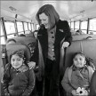
“Good night … good night,” Burke says. “Hoods up! Prayer hands! Watch the weather! I love you … .” A middleschool boy pauses, beaming. “I’ve got 792 points in First in Math!” Then he shoulders his backpack and heads into the Camden rain.

