Published in Print: August 20, 2014, as Researchers Find Clues in Ways Students Get Help With Classwork

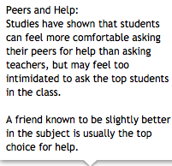
By Sarah D. Sparks
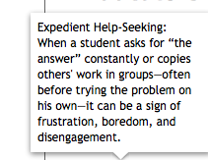

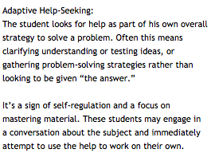
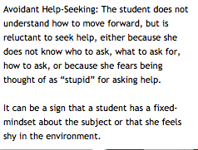

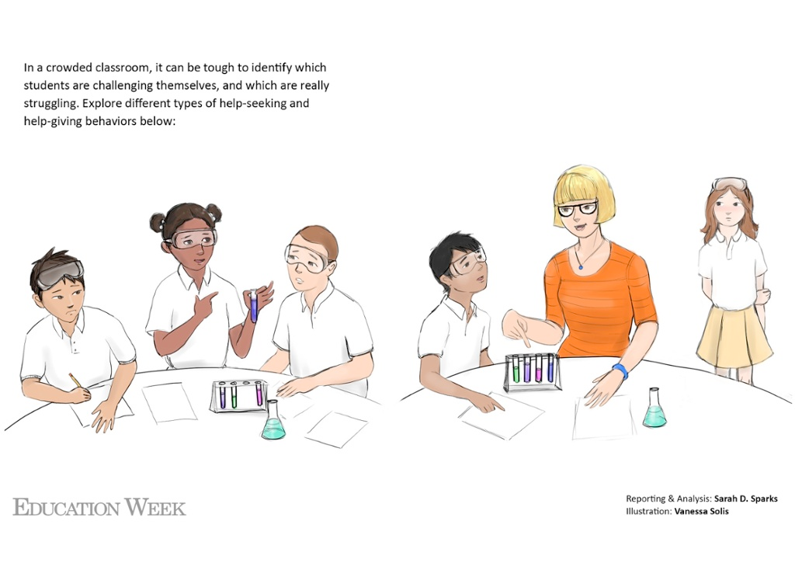

If you need help, raise your hand.

It's one of the first lessons of school, but as more students learn in and out of classrooms, in person and online, educators and researchers are starting to take another look at how students learn to ask for help.

In a typical classroom, teachers may see some students who raise their hands constantly, while others try to overhear the response to another student's question without ever asking their own. Some students online hit the "help" button over and over to get straight to the answer, while others seek advice on problem-solving strategies. These behaviors can tell educators and researchers a lot about what a student thinks about learning, his or her engagement in the subject, and the student's confidence in the support of teachers and peers.

That makes help-seeking behaviors uniquely useful as educators and policymakers look for ways to improve not just students' test scores, but the deeper "academic mindsets" that form a foundation for student learning—among them, perseverance, intellectual curiosity, and a "growth mindset," the belief that ability and knowledge in a particular subject is gained through experience rather than being innate.

"Help-seeking is actually part of the process of self-regulation," said Sarah M. Kiefer, an associate professor of educational psychology at the University of South Florida, in Tampa. While it's difficult to nail down what "perseverance" looks like in a classroom, she said studying help-seeking can provide not only clear measures of students' mindsets, but also an opening to strengthen students' learning skills.

"It's something that's very visible in the classroom, which makes it great for teachers," Ms. Kiefer said.

To get help successfully, a student has to understand that he or she has a problem, decide whether and whom to ask for help, do so clearly, and process the help that's given, said Stuart A. Karabenick, a research professor studying help behaviors at the University of Michigan school of education, in Ann Arbor. Some students ask for help before they even start thinking about a problem, while others avoid seeking help even after struggling fruitlessly on their own.

Whether a student is managing academic help appropriately can depend on the subject, the classroom context, and the student's own personality.

"The term 'help-seeking' suggests a deficit, but we need students to think of this as managing resources to solve a problem," Mr. Karabenick said. "You are always in the process of learning, and therefore you never know as much as you should. One has to learn the skills to acquire the knowledge you need."
Afraid to Ask

That doesn't mean students—or even many teachers—are comfortable asking for help.

"Help-seeking is both academic and social in nature, and adolescents are looking at their classroom as an academic and social minefield," Ms. Kiefer of the University of South Florida said.

As students move from elementary to middle and high school, the costs of looking foolish in front of their teacher and classmates starts to weigh heavily in their decisions about how and when to get help.

In one 2012 study, educational psychologist Allison M. Ryan of the University of Michigan found that as children got older, they became less likely to ask classmates for help in understanding concepts, but far more likely to get "expedient" help—like copying homework.

Similarly, in a forthcoming study of 6th grade girls, Ms. Kiefer and her colleagues found students reluctant to ask for help from students who were more popular than they were, but also unlikely to ask for help from students perceived to be the top of the class in that subject: It was just "too risky" socially.

Expedient help "is not cheating exactly, but they are like, 'I just want to get the homework done,' " Ms. Kiefer said. "It's less threatening to their self-efficacy and self-worth" than to admit they don't understand the lesson.

Differences in help-seeking can exacerbate achievement gaps between students.

Ms. Kiefer's research has found students from low-income and working-class families are often taught that they should not "bother" the teacher by asking for help, while middle-class students are often taught to be "squeaky wheels" and ask for help aggressively. While teachers often appreciated the working-class students' politeness and patience, they were also more likely to overlook them in favor of giving help to the more assertive students from better-off backgrounds.

Ms. Ryan and Ms. Kiefer have been exploring how teachers can use peer study groups and tutoring to boost students' confidence in asking peers for help.

"We have to figure out, what are students really striving for in the classroom, not just academically but also socially?" Ms. Kiefer said. "If you can take away the mindset that 'I don't want to look like a loser,' and promote a growth mindset, that's huge," she said.
When Helping Hurts

If students who actively ask for help get more support in the long term, does that mean students will learn more if they all become squeaky wheels? Not necessarily: Too much help can hurt as much as too little.

"Too often, we don't give students the opportunity to make sense by themselves," said Ido Roll, a researcher on students' help-seeking behavior and the senior manager for research and evaluation in the Center for Teaching, Learning, and Technology in the University of British Columbia, in Canada. "We do know that students kind of like to ask for too much help; over and over again [in online systems], students will ask all the way up for all the help they can."

While online courses can make it easier for more reserved students to ask for help, Mr. Roll said they do increase the risk that students will focus on expedient help rather than help that improves learning, such as problem-solving strategies. It's harder to simply ask for "the answer" in a live class discussion, he said.

In one study published this past spring in the Journal of the Learning Sciences, Mr. Roll and colleagues at Teachers College, Columbia University, in New York City and Pittsburgh's Carnegie Mellon University tracked when high school students with high and low math skills asked for help on a computer-based geometry-tutoring program.

As might be expected, the students who overused the help feature of the program—who simply clicked through to the answer, for example—learned less in the end, and students who asked for help primarily on the

most-challenging questions learned more in general. Interestingly, students with little prior knowledge of a particular question learned more when they avoided help and instead tried and failed repeatedly.

Mr. Roll and his colleagues also suggested that low-skilled students may not have enough prior knowledge to understand high-level help given.

Think of giving dining suggestions to two people—a native of your city and a visitor. The native resident, like the student with high math skills in the study, understands the layout and traffic of the city enough to benefit from somewhat convoluted, backroads directions to the hot new hole in the wall. The visitor, like the low-skill student, might be more confused by your insider knowledge and would benefit more from either a longer, straighter path to the restaurant or the opportunity to stroll around and explore a restaurant district.

"Too often, we are adding cognitive load when we give help," Mr. Roll said, because the information provided by a teacher or computer program often still requires a basic level of understanding of the subject, which a student may not have.

"I'm all for giving help, but giving help is not telling you what to do; it's giving resources to help you make sense of it yourself."
Setting the Tone

That can be challenging even for experienced teachers.

"Teachers may not know why students don't ask for help," Mr. Karabenick of the University of Michigan said. "It may be that I don't know what I don't know; I don't know how to ask; I'm afraid to ask; or I just don't need help.

"One of the major skills a teacher needs," he said, "is to be able to distinguish among these, … but teachers by and large are not given any training in help-seeking, and they may not be comfortable asking for help themselves."

Sidney D'Mello, an assistant professor of computer science and psychology at the University of Notre Dame, is using facial-tracking cameras and seat sensors to analyze the differences in facial and body posture associated with different emotions of learners in the classroom.

For example, students intensively engaged in their work who likely do not need help—those said to be "in the flow"—lean forward in their seats and look intent, in a way that can seem similar to that of a student who is confused and frustrated. But Mr. D'Mello and his colleagues found that students actually in the flow lean forward more steeply, leaving the backs of their chairs a bit, while frustrated students lean forward but remain upright in their body posture.

The researchers are hoping to make it easier for software programs and people alike to recognize subtle differences in students' postures that might signal when they need help but are uncomfortable asking for it.

From the first day of school, teachers can set the tone in their classrooms to improve help-seeking. For example, Mr. Karabenick found that in classes where teachers give short answers to complex questions, students become less likely to ask for help over time.

Teachers in lower grades typically start the year showing students the etiquette for asking questions—building on that old sequence of raise your hand, wait to be called on, and so on. Mr. Karabenick advises also talking with students about when and whom they can ask for help, and letting them role-play different scenarios.

"Make it explicit, let them practice it. ... It can be very, very effective to make it transparent that this is a normal part of learning," he said.

Vol. 34, Issue 01, Pages 1,16
You must be logged in to leave a comment. |

