16 Apr 2014 The Philadelphia Inquirer By Anndee Hochman

Making most of children’s play
Playworks is bringing recess back to Philadelphia. The national program teaches fairness, impulse control, freewheeling fun.
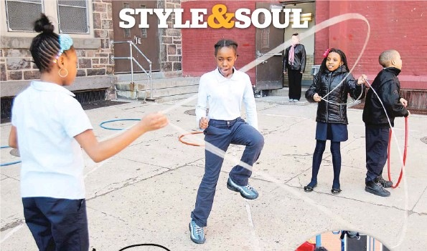
Playworks is bringing recess back to Philadelphia. The national program teaches fairness, impulse control, and freewheeling fun. On a sun-crisp Friday morning at Kearny Elementary School in Northern Liberties, a brisk game of four-square comes to a sudden halt. “You’re out!” declares fourth grader Jayah Grimes to classmate Sa’hid Jones. “No, you are!” the boy counters.

The other players — two on the court, a handful waiting their turns — watch as Grimes and Jones face off. “One, two, three, RoShamBo!” they chant, the call for a round of “rock, paper, scissors.” Grimes makes the gesture for scissors, but Jones throws the flat-palmed sign for paper. She’s in, he’s out, and the game, to everyone’s relief, goes on.
The dispute might have ended differently before Playworks came to town. The national program, which landed in Philadelphia four years ago, puts full-time “recess coaches” in 15 participating city schools to teach kids games like four-square and kickball — and, more important, to help a generation unskilled in the way of free play to interact in a way that’s fair and fun. That means learning to say good try in stead of haha! You’re out! It means tagging someone with “butterfly fingers” on a shoulder instead of a thwop to the ribs. And it means resolving common playground conflicts — whose turn is next, whether the ball was out of bounds — with a quick round of RoShamBo.
After years in which many schools trimmed recess in order to spend more time drilling math and reading, the success of Playworks — now operating in 23 communities and 382 schools nationwide — is an indication that the jump rope may be swinging the other way.
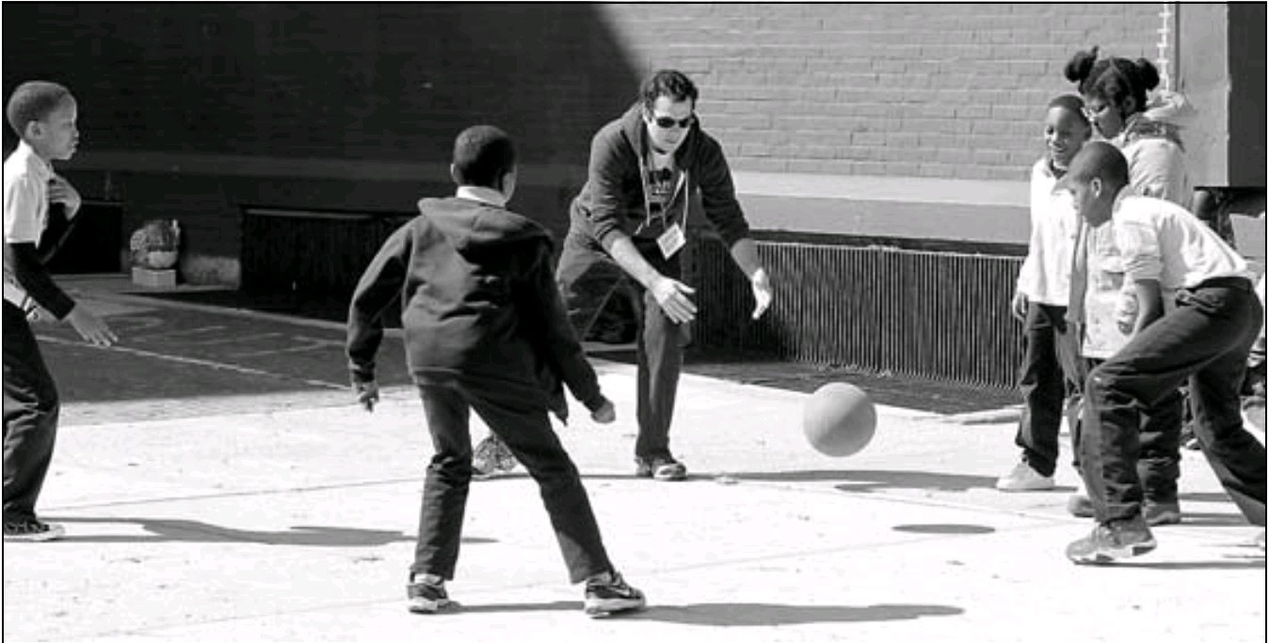
Chicago public schools reinstated recess in 2012 after a three-decade hiatus. Teachers and principals, including the 300 who attended a daylong Education Summit in Camden last month, now tout “social-emotional learning” skills like collaboration, problem-solving, and impulse control as key to kids’ success. And the American Academy of Pediatrics (AAP) noted in a 2013 policy statement that a “safe and well-supervised recess offers cognitive, social, emotional, and physical benefits.”

Which is, more or less, the opinion of Naima Campbell, a Kearny fifth grader who waits her turn to shoot baskets. Kearny’s coach, Lauren McGuire — “Coach Mac” to the kids — buzzes around the hardtop, reminding kids to stay out of the dirt, using call-and-response to get a group’s attention (“I say ‘basket,’ you say ‘ball’!”), and accepting a fourth grader’s invitation to a spontaneous jump-rope contest.
“If it wasn’t for Coach Mac, everybody would be running around, arguing and being mean to each other,” Campbell says. “Now we solve the problems. We take turns. We tell people to calm down. It’s all just a game.”
Playworks started in Oakland, Calif., 18 years ago, when an elementary-school principal challenged Jill Vialet, a longtime art educator, to “fix recess.”
Vialet, 49, noticed that kids weren’t playing outside anymore. In poor urban neighborhoods, the streets weren’t safe. In more affluent areas, parents shuttled children from violin lessons to karate class, with little time for unsupervised play.
“The culture of play had really fallen away,” Vialet says. “At recess, there would be a few kids playing and a lot of kids on the periphery trying to stay out of harm’s way. It felt stressful. It didn’t feel playful.”
Playworks began with two schools. That grew to seven, then 14. In 2005, the Robert Wood Johnson Foundation (RWJF) gave Playworks $4.4 million to pilot the program in three cities outside California. Three years later, the foundation forked over $23.7 million more to take Playworks nationwide and evaluate its success.
In Philadelphia, as in other cities, the program focuses on lowincome elementary schools where at least 50 percent of children qualify for free or reduced-price lunch. Playworks is not cheap — $60,000 for a full-time coach who guides recess, conducts individual “class game times” with every grade, leads before- and afterschool programs, and works with teachers and staff. Each school contributes $26,500; at Kearny,
the Home and School Association raised that money.
Principals, teachers and parents say Playworks is worth the price. Kearny principal Daniel Kurtz says the number of suspensions for pushing or fighting at recess have dropped. “It’s more than just controlling a recess; it’s learning to play, to share, to get along,” he says. Nationwide, school staff agree: According to the RWJF-funded study, 91 percent of teachers said the program helped students stay out of trouble.
What’s more, teachers said on Playworks’ 2013 survey that they recovered an average of 26 hours’ teaching time because children returned from recess calm, energized, and ready to learn.
Playworks has even won endorsement from Lenore Skenazy, author of Free-Range Kids: How to Raise Safe, Self-Reliant Children (Without Going Nuts With Worry) and a frequent critic of the ways adults micromanage children’s lives. “When I first heard about Playworks, I made fun of it: You’re teaching kids how to play? That’s ridiculous!” Then Skenazy attended a Playworks conference, where she pretended to be a chicken in a cooperative game. “They were clever, goofy games. It was so fun! And I could see the direct connection between playing and learning.”
Across town from Kearny, at C. W. Henry School in West Mount Airy, Playworks coach Dan Whelan is about to lead “class game time” with a group of fourth graders, a weekly session designed to build particular skills, such as clear communication or teamwork.
Whelan, like McGuire, is an AmeriCorps volunteer, trained by Playworks to guide the highoctane energy of grade-schoolers who have spent too many winter days cooped indoors. He claps in rhythm to get their attention, then explains the game: Students will stand in a circle and pass a large ball by calling a classmate’s name, then tossing; the key is to remember the pattern of tosses, so they can repeat it, even faster, the next time.
The group’s teacher, Micah Gillum, watches from the sidelines. He has been at Henry for 14 years and remembers the chaos that recess used to be. “Playworks teaches the kids sportsmanship and cuts down on the conflicts. Now I see kids using RoShamBo to decide whose turn it is in class.”
By the time the bell is about to ring, one girl has developed a spontaneous nosebleed and a boy is turning exuberant cartwheels on the hardtop. Whelan, unfazed, gathers the kids for a final cheer.
“What are we?” “A team!” “What do we do?” “Work!” “What does that make?” “Teamwork! Teamwork!!” As a pack, they race for the school door. But Iroquois Dickerson stays behind. “Coach Dan, when’s our next class game time?”

